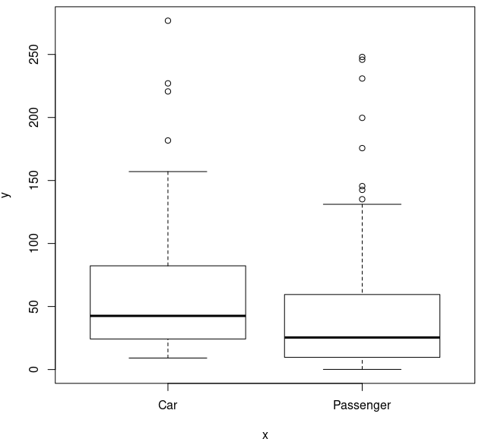
Data Analysis Project
By: Max Ooi Wei Xiang

Understanding the Problem
I want to understand what factors influence the sales of a car.

Plan and Properly Collect Relevant Data
Data from Kaggle (https://www.kaggle.com/datasets/gagandeep16/car-sales) is used as a primary data source.

Explore Data
After taking the interesting features, omitting the NA values and removing 1 outlier, we are left with 151 rows. Columns with discrete levels are Manufacturer and Vehicle_type. Running a pairwise plot shows a high degree of correlation between Horsepower and Power_perf_factor, hence the latter was ignored.
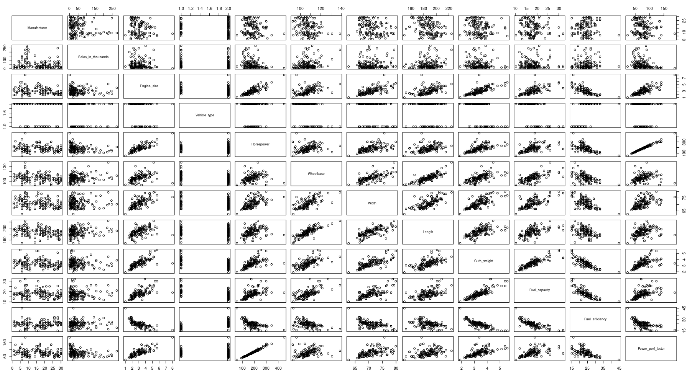

Plotting the sales against Vehicle_type, the difference between Car and Passenger type is relatively small, hence Vehicle_type is ignored in the model to reduce complexity.

Plotting the sales against Manufacturer, it is apparent that the Manufacturer has a big influence over the mean and variance of the sales.
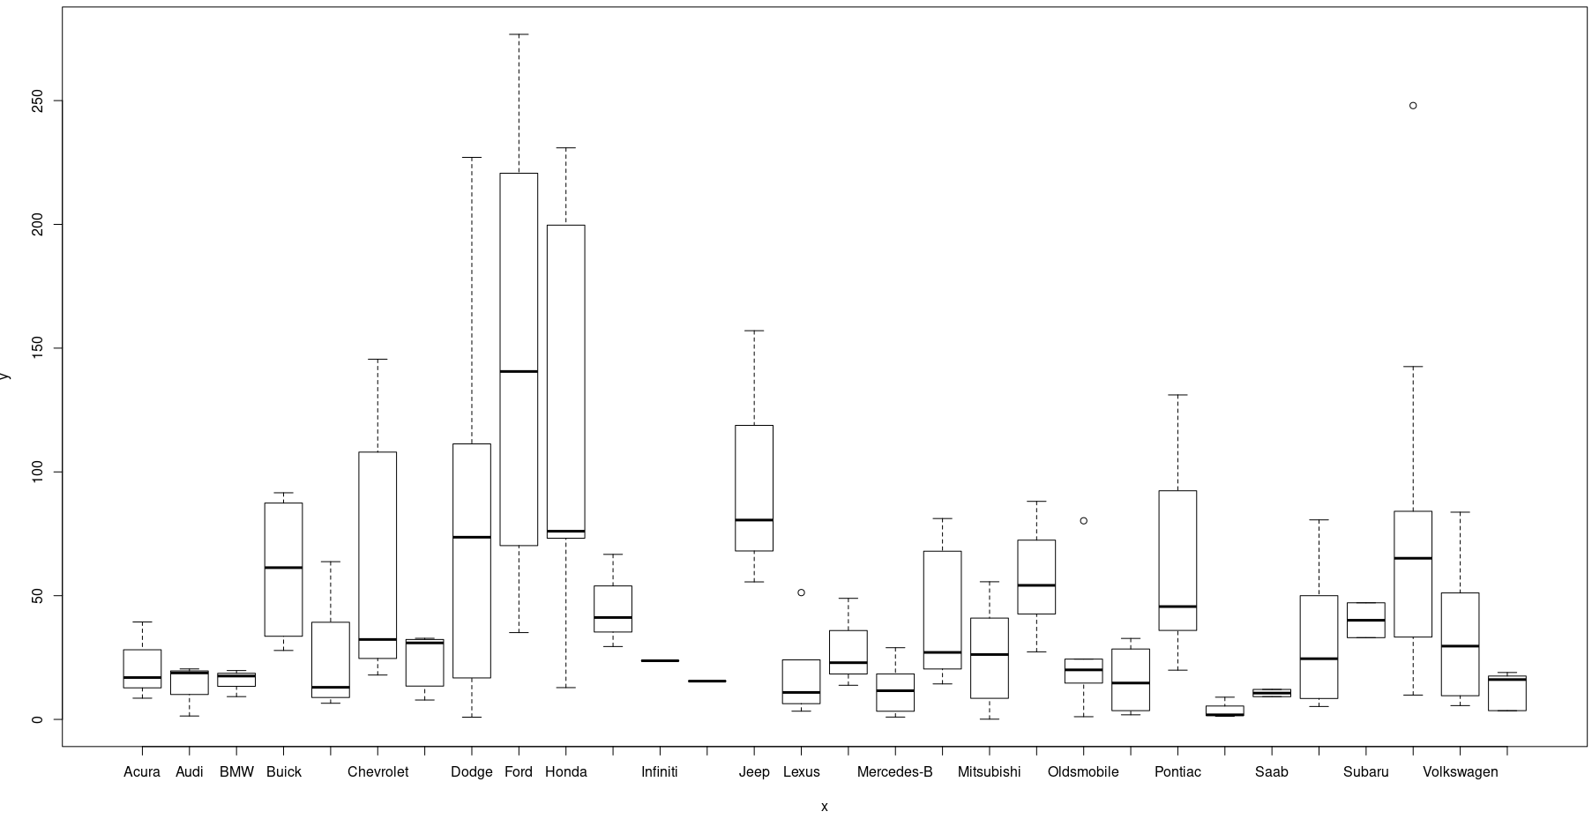

Postulate a Model
To reduce the complexity of the model, Manufacturers are first grouped together based on their similar distribution. The table below shows the grouping. This produces 9 levels for Manufacturer.

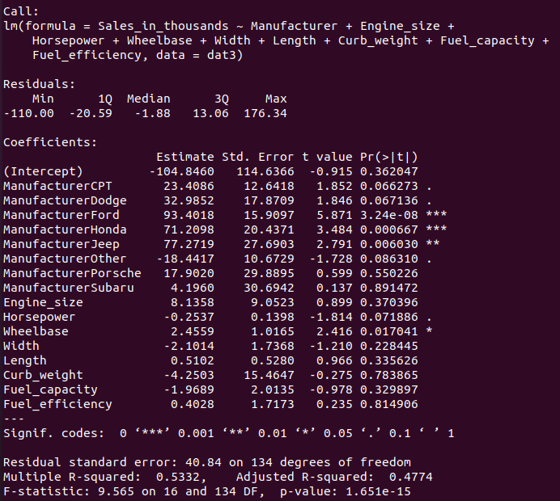  Group Name | Manufacturers
Ford | Ford
Honda | Honda
Jeep | Jeep
Porsche | Porsche
Subaru | Subaru
CPT | Chevrolet, Pontiac, Toyota
Dodge | Dodge
BMNV | Buick, Mercury, Nissan, Volkswagen
Other | Other

A preliminary linear model is fitted to act as feature selection, shown on the right. It can be seen that, among the existing features, Fuel_efficiency and Curb_weight have the lowest t values. Hence, they are removed from feature list, resulting in the final feature list of Engine_size, Horsepower, Wheelbase, Width, Length, and Fuel_capacity, on top of Manufacturer.

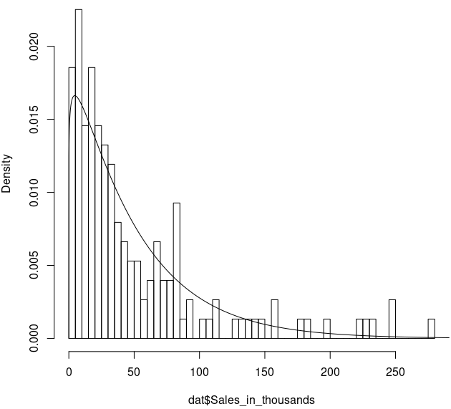
As we established that Manufacturers influence the mean and the variance of the distribution, a hierarchical model is proposed. A gamma distribution is used for the prediction of sales, with the alpha and beta calculated from the mean and the standard deviation. The mean is a linear model of the 6 built-in features. The intercept of the linear model, as well as the standard deviation, are functions of Manufacturer.

Fit the Model
The model was fitted with 10 000 points of burn-in, followed by 500 000 points of sampling. A scale reduction factors of at most 1.12 is achieved, with only 3 parameters being above 1.02 out of 24 parameters tracked (9 intercepts, 9 standard deviations, 6 coefficients). A mean deviance and penalty of 1377 and 69.7 was achieved.

Check the Model
On the left is a plot of the predicted expected value for each observation against the actual sales. On the right is (sales – expected value) against manufacturer. Although the model can fit the general trend, it is obvious that the variations are too high for this model to be useful. It can also be seen that variance increase with sales. Manufacturers with the highest variance (Ford, Honda and Dodge) are also the manufacturers with the highest sales.
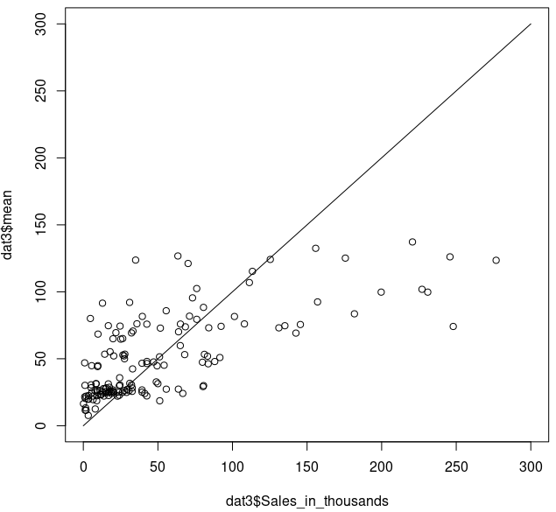
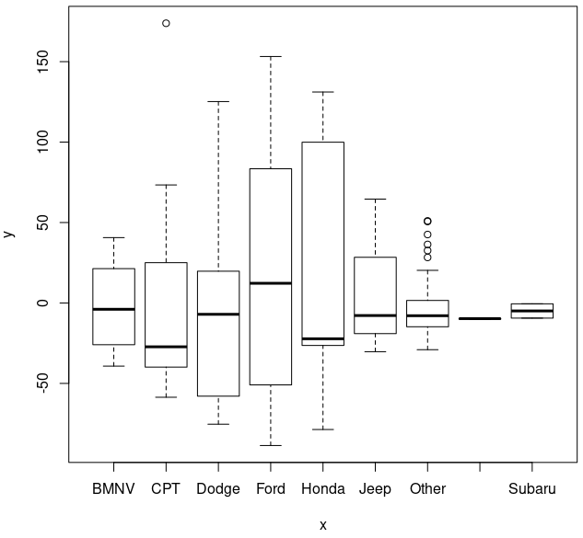

Iterate if Necessary
For the next iteration, perhaps try higher-order terms and interactions could help to capture more complex behaviours. Making coefficients dependent on the manufacturer might also help to better fit the model.

Use the Model
Need to refine model before use.

